Practical 6

**Aim : Develop application to download image/video from server or upload image/video to server using MTOM techniques**

**Step1: create project**

**Step2: create 2 folders name as download and upload and in same path save any image**

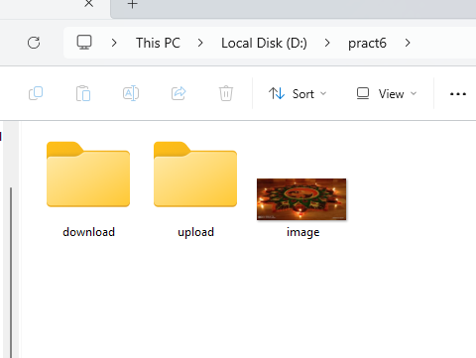

**Step3: right click on project name >new> jsp >give name as index.jsp**

**Insert code:**

<%@page contentType="text/html" pageEncoding="UTF-8"%>

<%@page import="java.io.BufferedOutputStream"%>

<%@page import="java.io.FileOutputStream"%>

<%@page import="java.io.FileInputStream"%>

<%@page import="java.io.BufferedInputStream"%>

<%@page import="javax.imageio.stream.FileImageInputStream"%>

<%@page import="java.io.File"%>

<%@page import="javax.xml.ws.soap.MTOMFeature"%>

<!DOCTYPE html>

<html>

<head>

<meta http-equiv="Content-Type" content="text/html; charset=UTF-8">

<title>JSP Page</title>

</head>

<body>

<%-- start web service invocation --%><hr/>

<% try {

pkg.ImageWS service = new pkg.ImageWS();

String filePath = "D:/pract6/image.jpg";

File file = new File(filePath);

FileInputStream fis = new FileInputStream(file);

BufferedInputStream bis = new BufferedInputStream(fis);

String uploadFilePath = "D:/pract6/upload/upload_image.jpg";

byte[] imageBytes = new byte[(int) file.length()];

bis.read(imageBytes);

service.upload(uploadFilePath, imageBytes);

bis.close();

out.println("File Uploaded : " + filePath);

} catch (Exception ex) {

throw ex;

}

%>

<%--end web service invocation--%> <hr/>

<%--start web service invocation--%> <hr/>

<%

try {

pkg.ImageWS service = new pkg.ImageWS();

String filePath = "D:/pract6/image.jpg";

String downloadFilePath = "D:/pract6/download/downloaded_image.jpg";

byte[] fileBytes = service.download(filePath);

FileOutputStream fos = new FileOutputStream(downloadFilePath);

BufferedOutputStream bos = new BufferedOutputStream(fos);

bos.write(fileBytes);

bos.close();

out.println("File Downloaded : " + downloadFilePath);

} catch (Exception ex) {

throw ex;

}

%>

<%--end web service invocation--%><hr/>

</body>

</html>

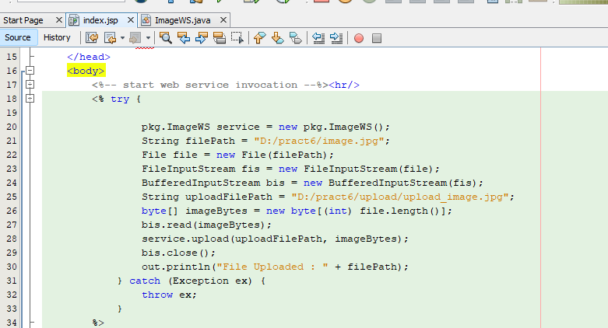

**Step4: right click on project name>new>java class >name as ImageWS**

**Insert code:**

package pkg;

import java.io.*;

import javax.jws.Oneway;

import javax.jws.WebService;

import javax.jws.WebMethod;

import javax.jws.WebParam;

import javax.xml.ws.soap.MTOM;

@MTOM(enabled = true, threshold = 60000)

@WebService(serviceName = "ImageWS")

public class ImageWS {

@WebMethod(operationName = "upload")

@Oneway

public void upload(@WebParam(name = "Filename") String filePath, @WebParam(name

= "ImageBytes") byte[] ImageBytes) {

try {

FileOutputStream fos = new FileOutputStream(filePath);

BufferedOutputStream bos = new BufferedOutputStream(fos);

bos.write(ImageBytes);

bos.close();

System.out.println("Recieved file :" + filePath);

} catch (Exception ex) {

System.out.println(ex);

}

}

@WebMethod(operationName = "download")

public byte[] download(@WebParam(name = "Filename") String filePath) {

System.out.println("Sending file :" + filePath);

try {

File file = new File(filePath);

FileInputStream fis = new FileInputStream(file);

BufferedInputStream bis = new BufferedInputStream(fis);

byte[] fileBytes = new byte[(int) file.length()];

bis.read(fileBytes);

bis.close();

return fileBytes;

} catch (Exception ex) {

System.out.println(ex);

}

return null;

}

}

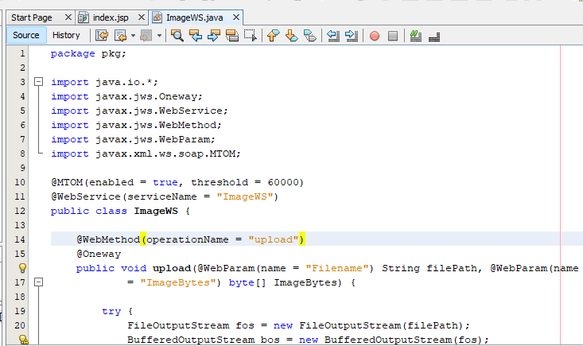

**Run index.jsp file then check in folders named as download and upload if image is uploaded then it successfully run.**



